**MAVEN CONFIGURATION**

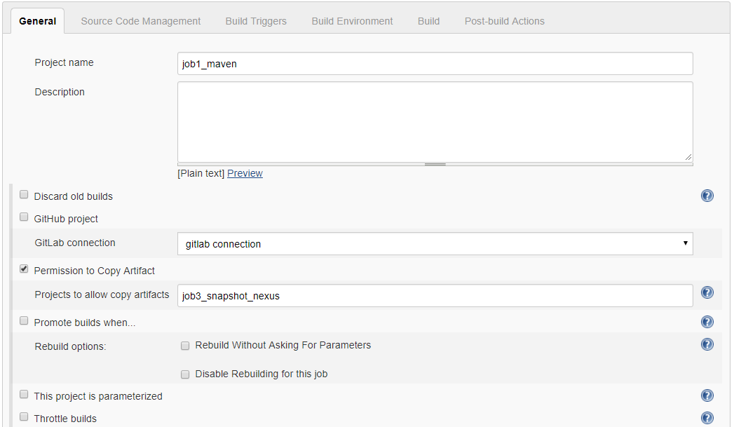

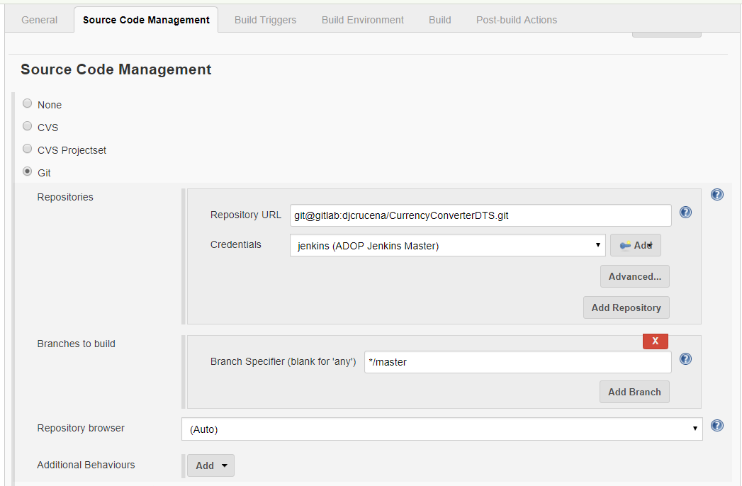

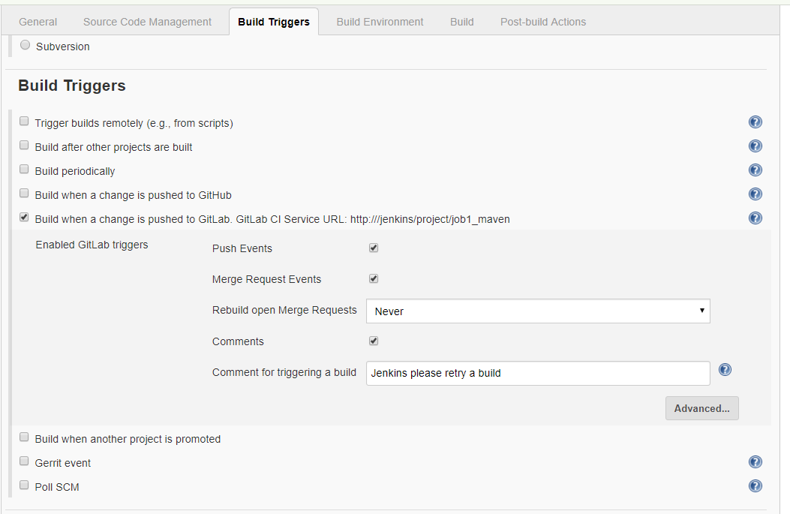

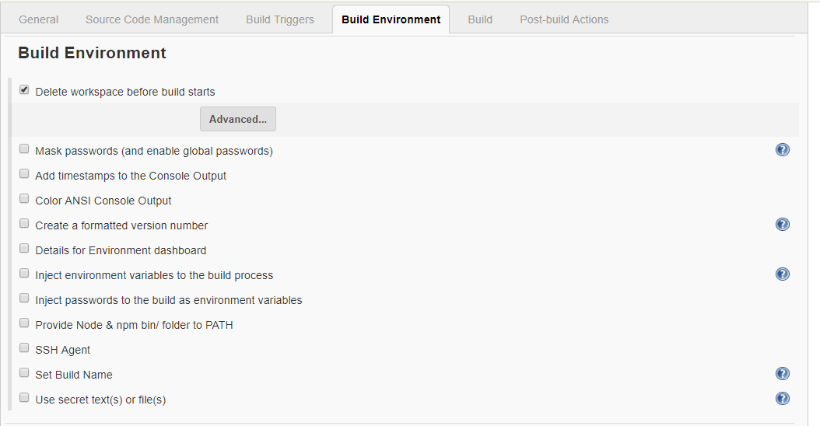

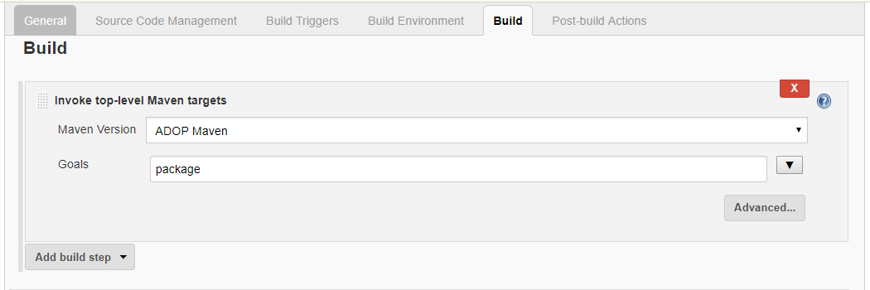

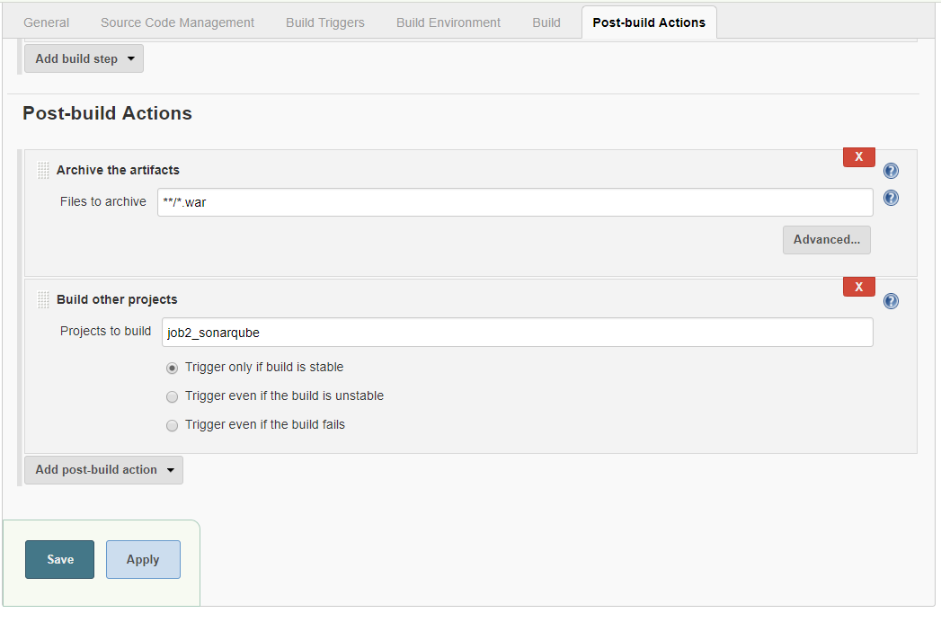

**SONARQUBE CONFIGURATION**

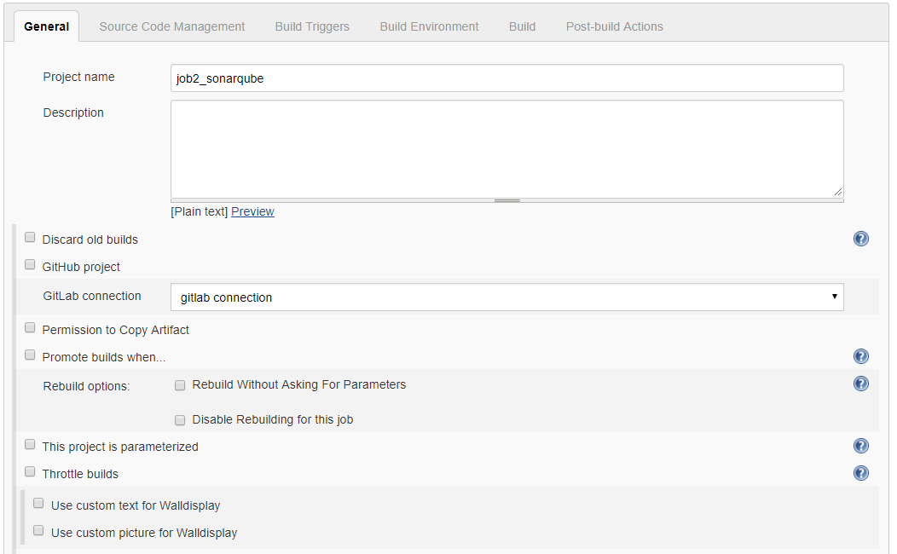

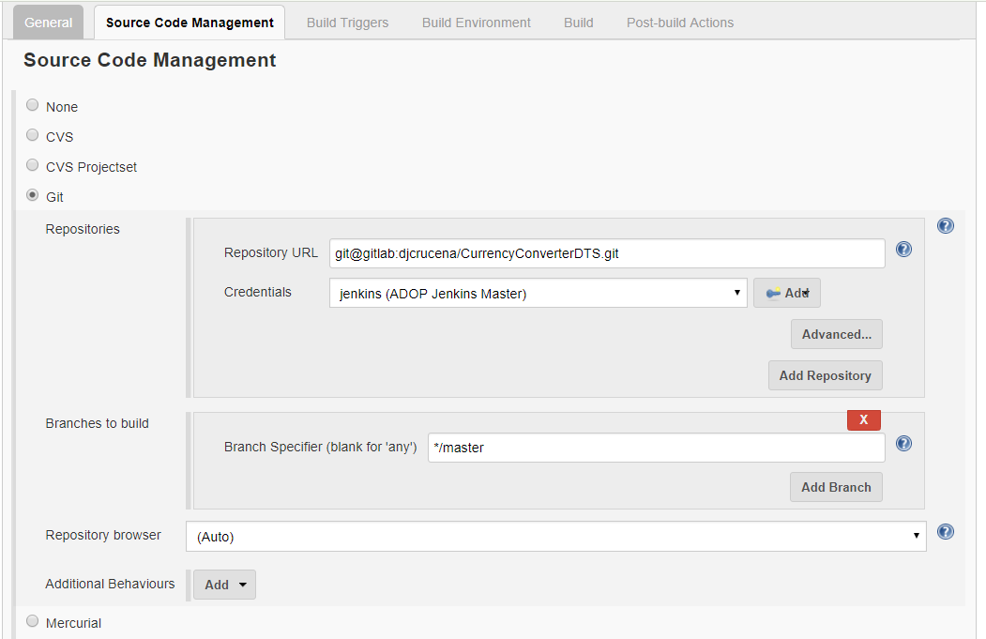

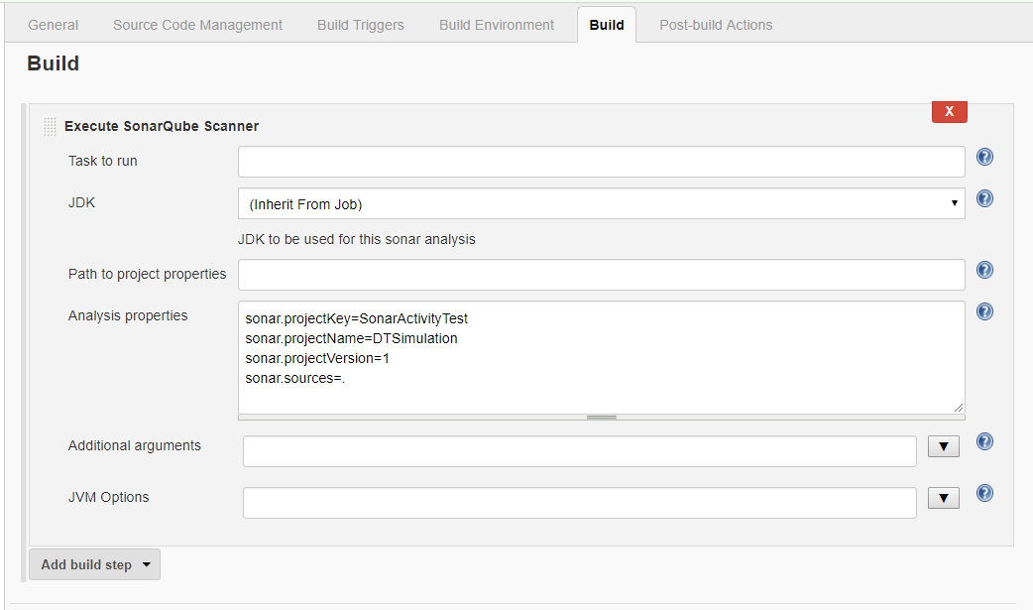

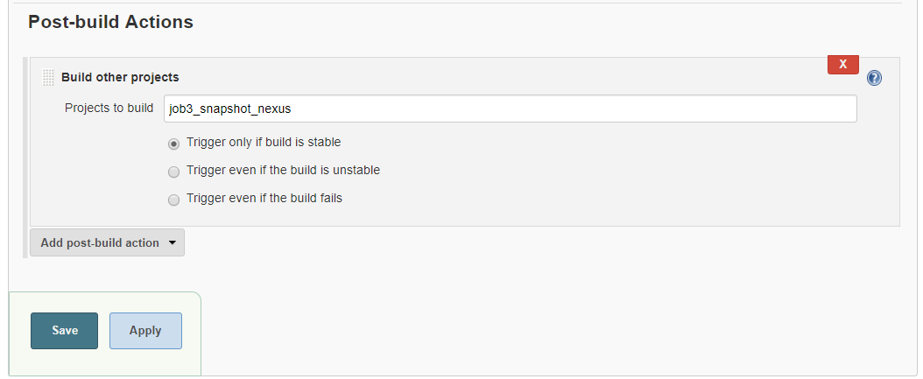

**SNAPSHOT NEXUS CONFIGURATION**

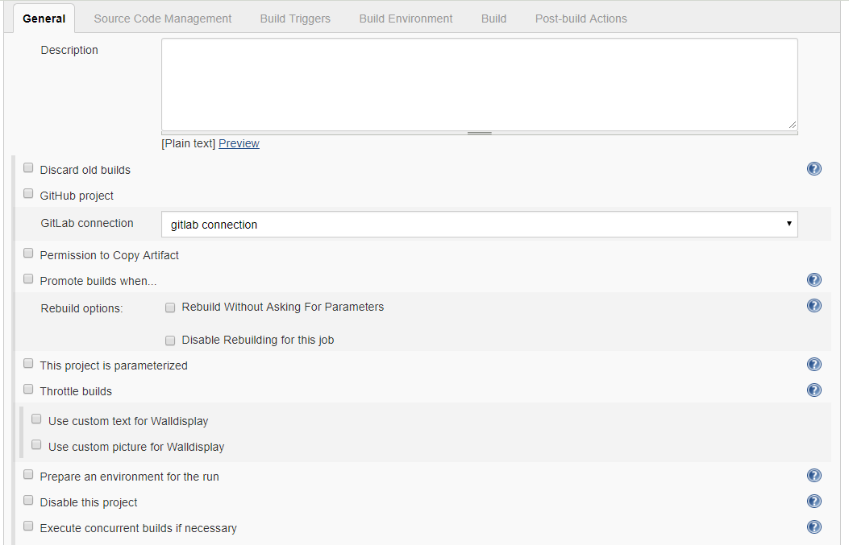

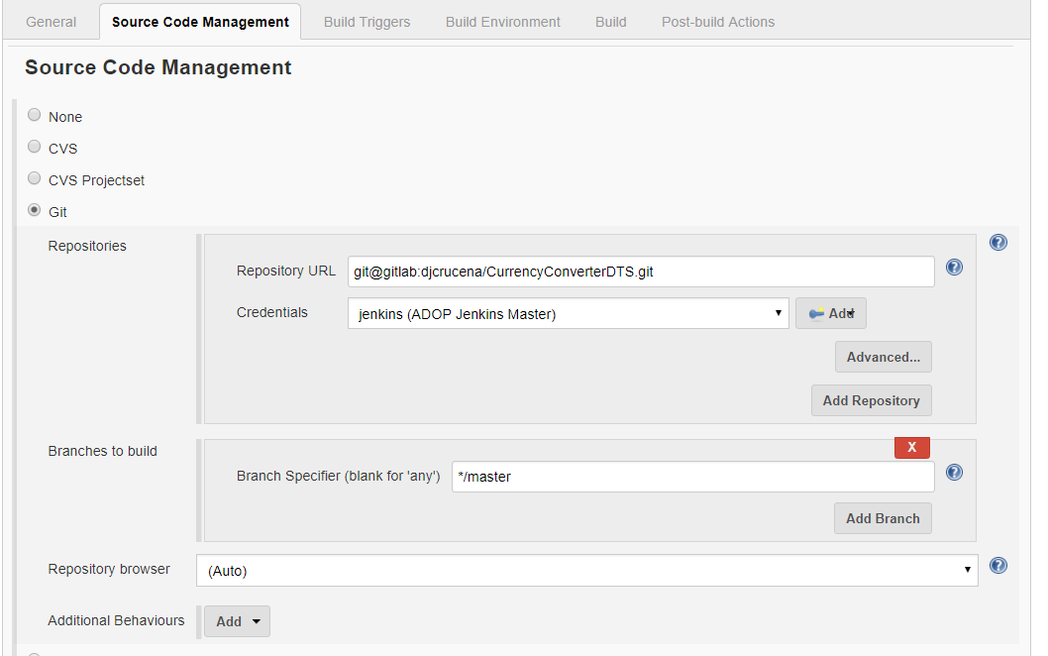

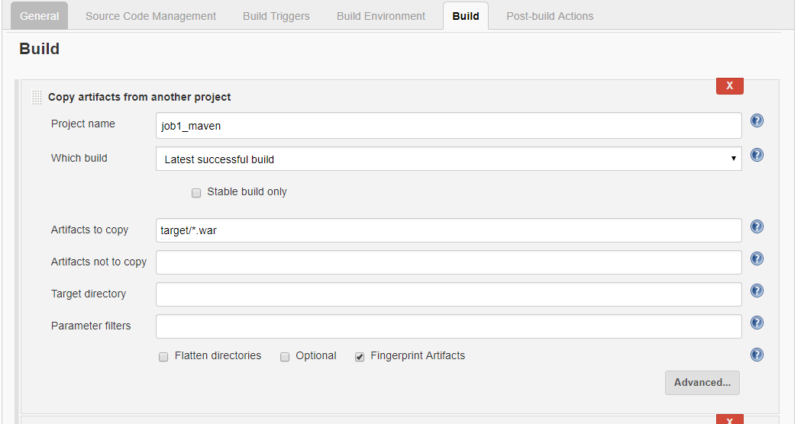

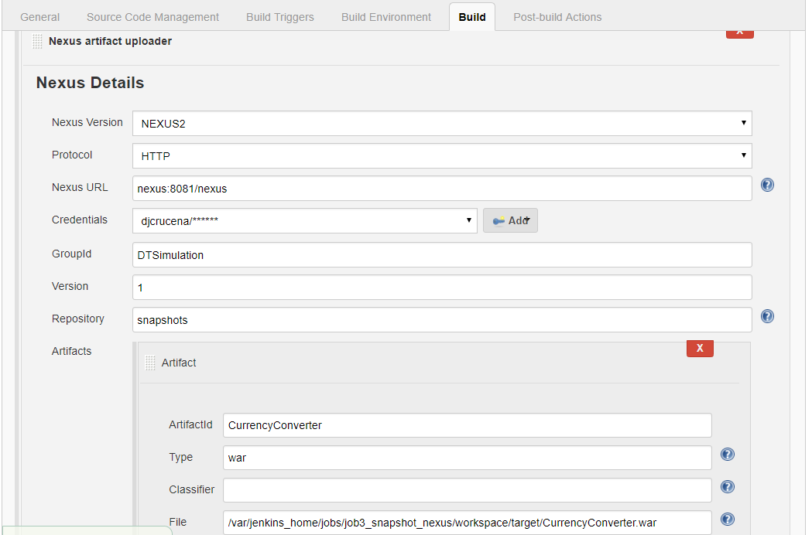

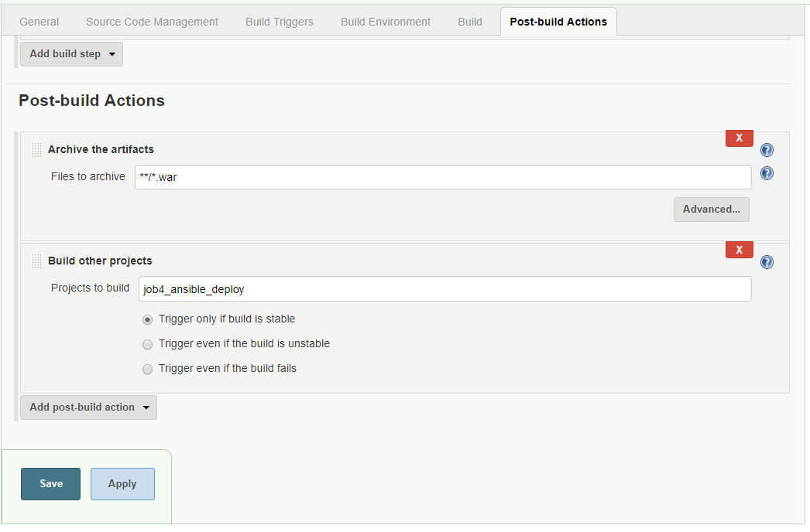

**ANSIBLE CONFIGURATION**

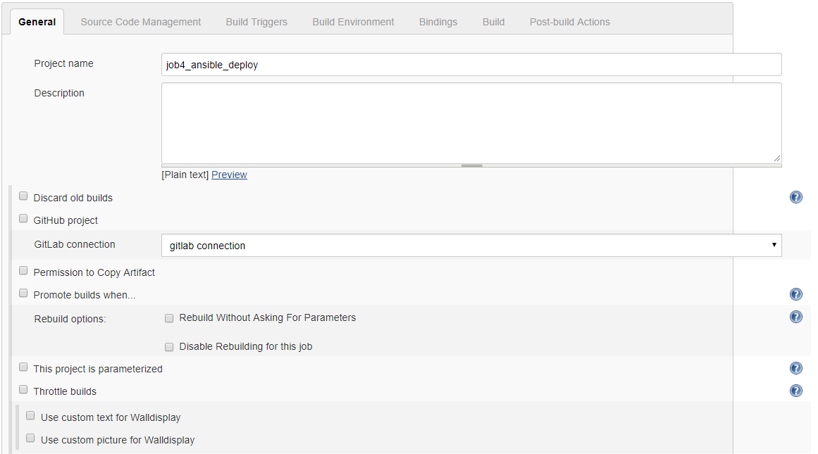

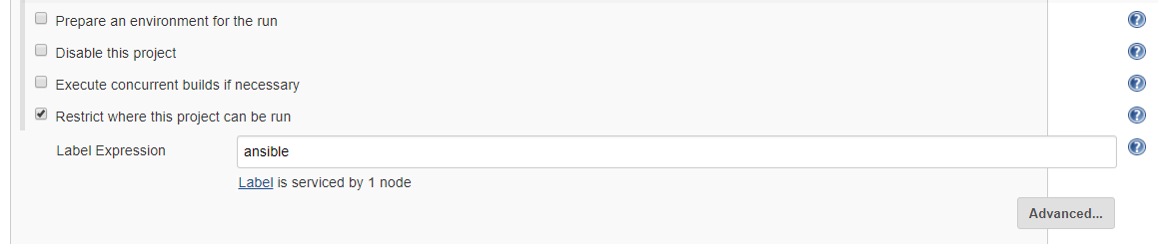

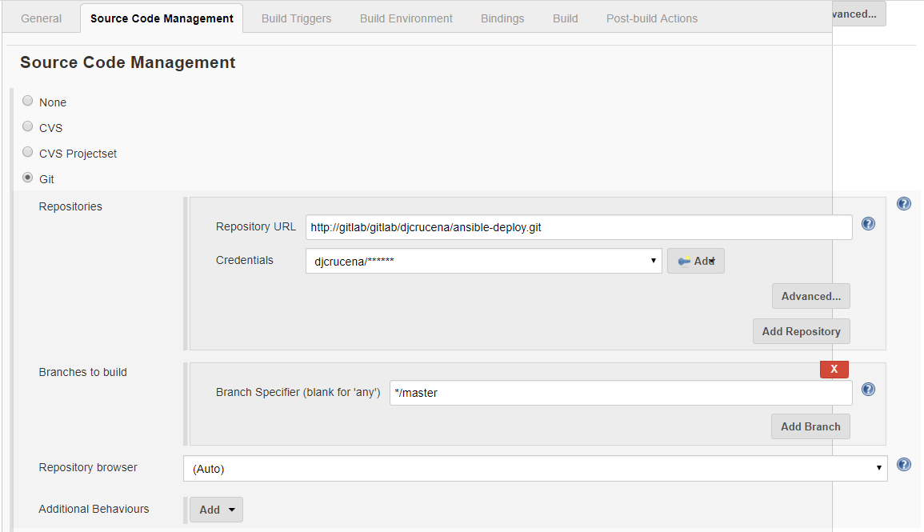

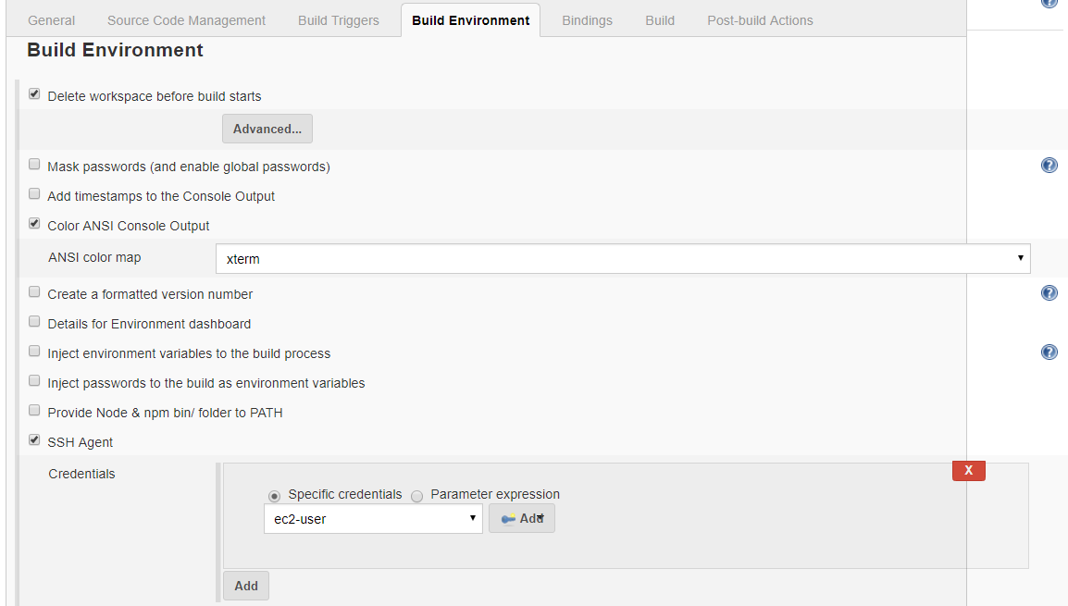

NAME: ec2-user

PEM FILE

ID: ansible-key



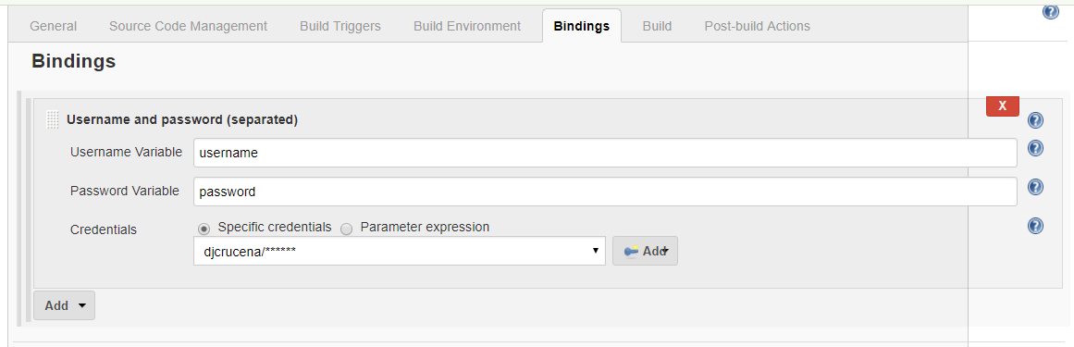

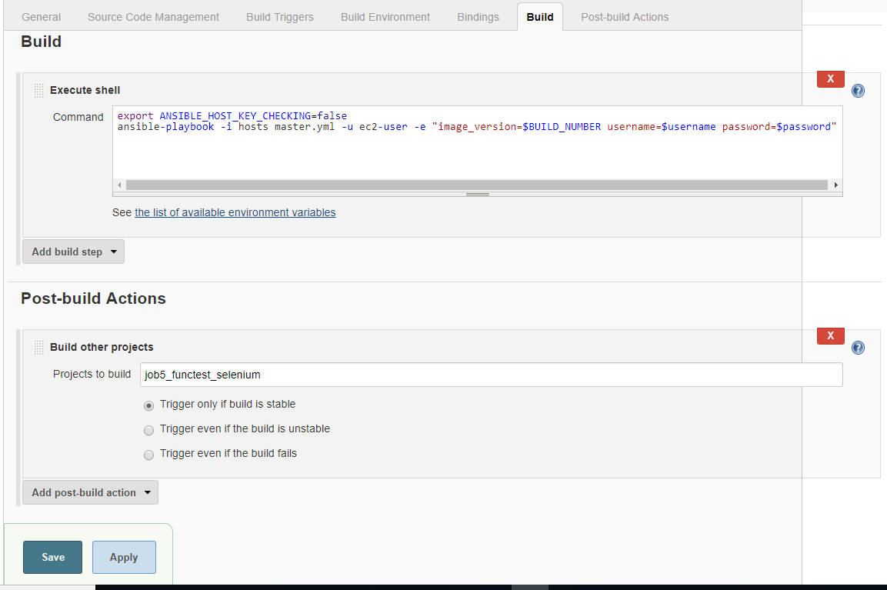

**SELENIUM CONFIGURATION**

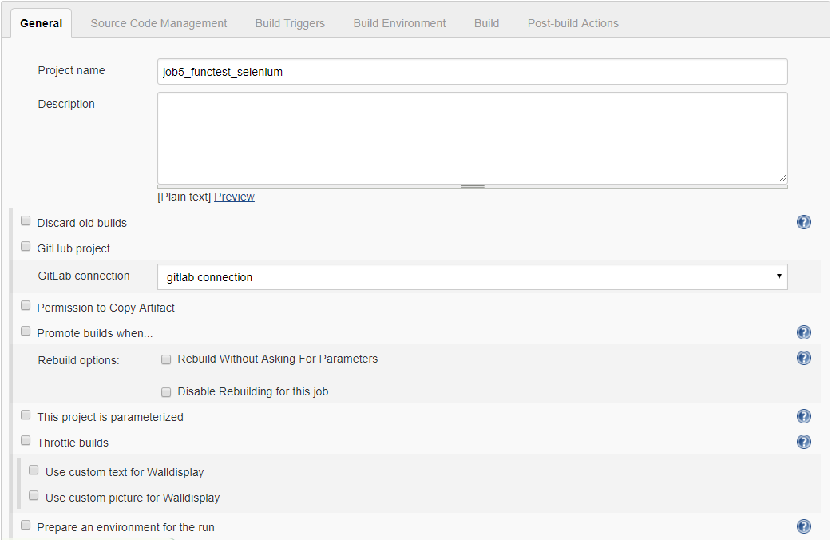

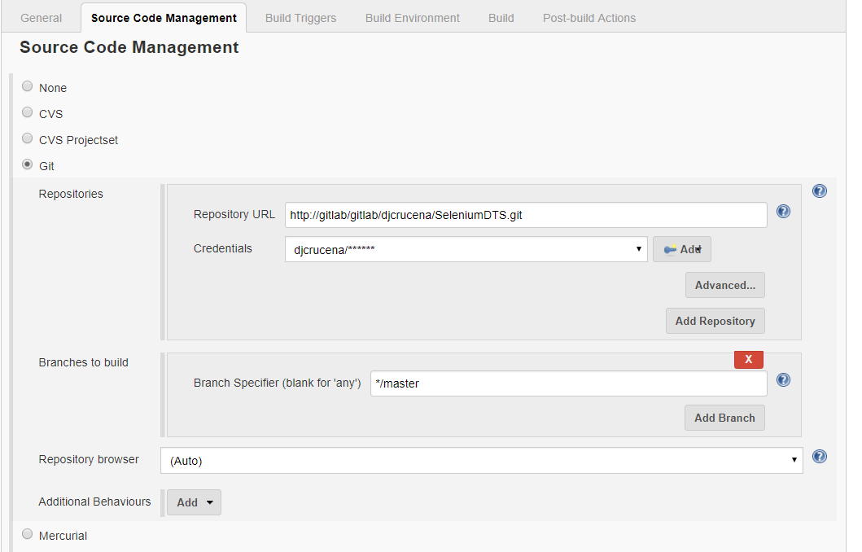

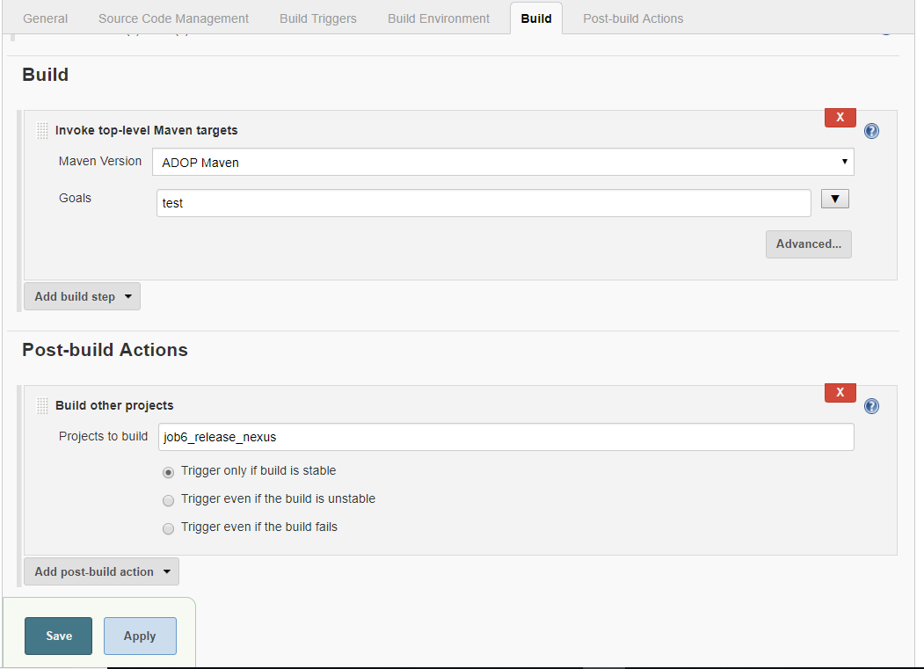

**RELEASES NEXUS CONFIGURATION**

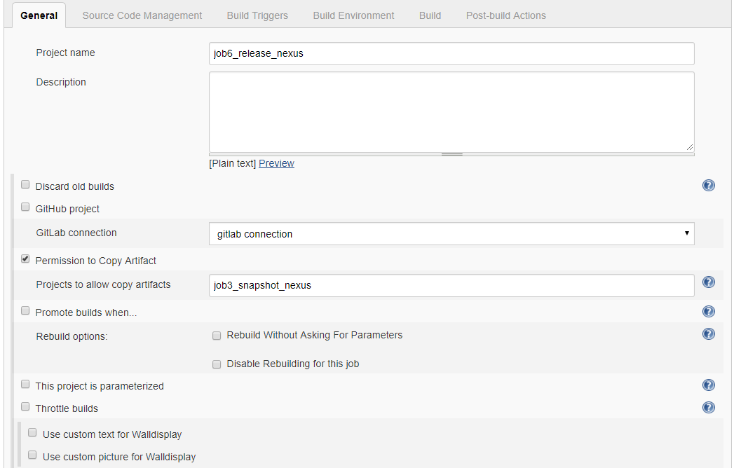

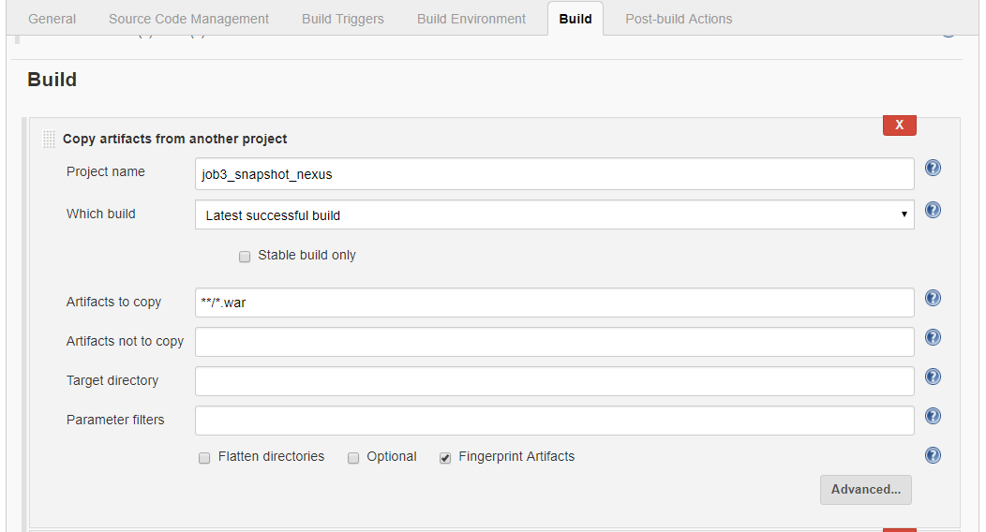  
  
  
  
  
  
  
  
  
  
  
  
  
  
  
  
  
  
  
  
  
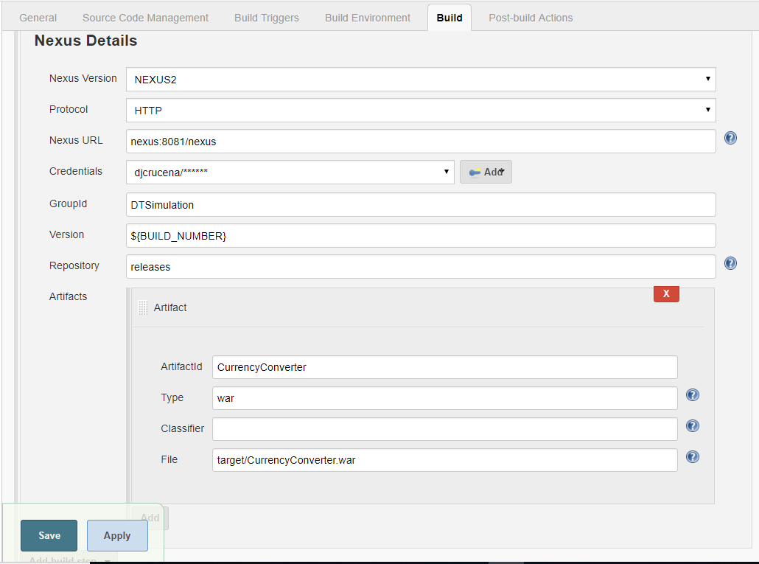  
  
  
  
  
  
  
  
  
  
  
  
  
  
  
  
  
  
  
  
  
  
  
  
  
PIPELINE

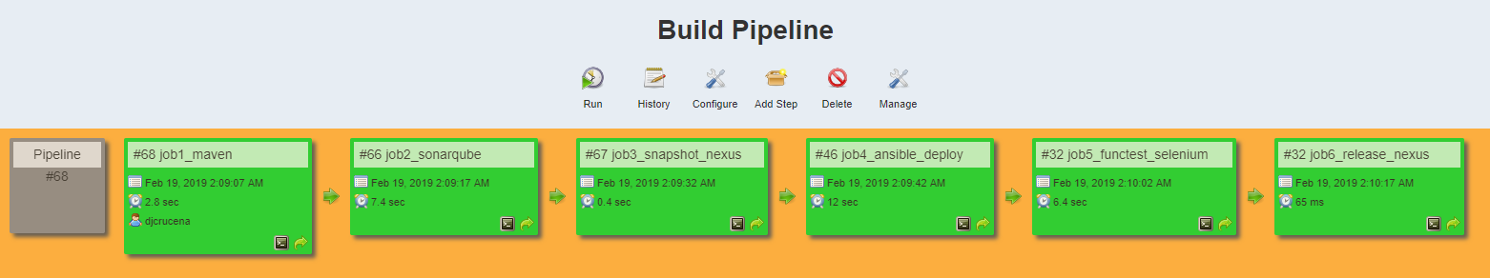

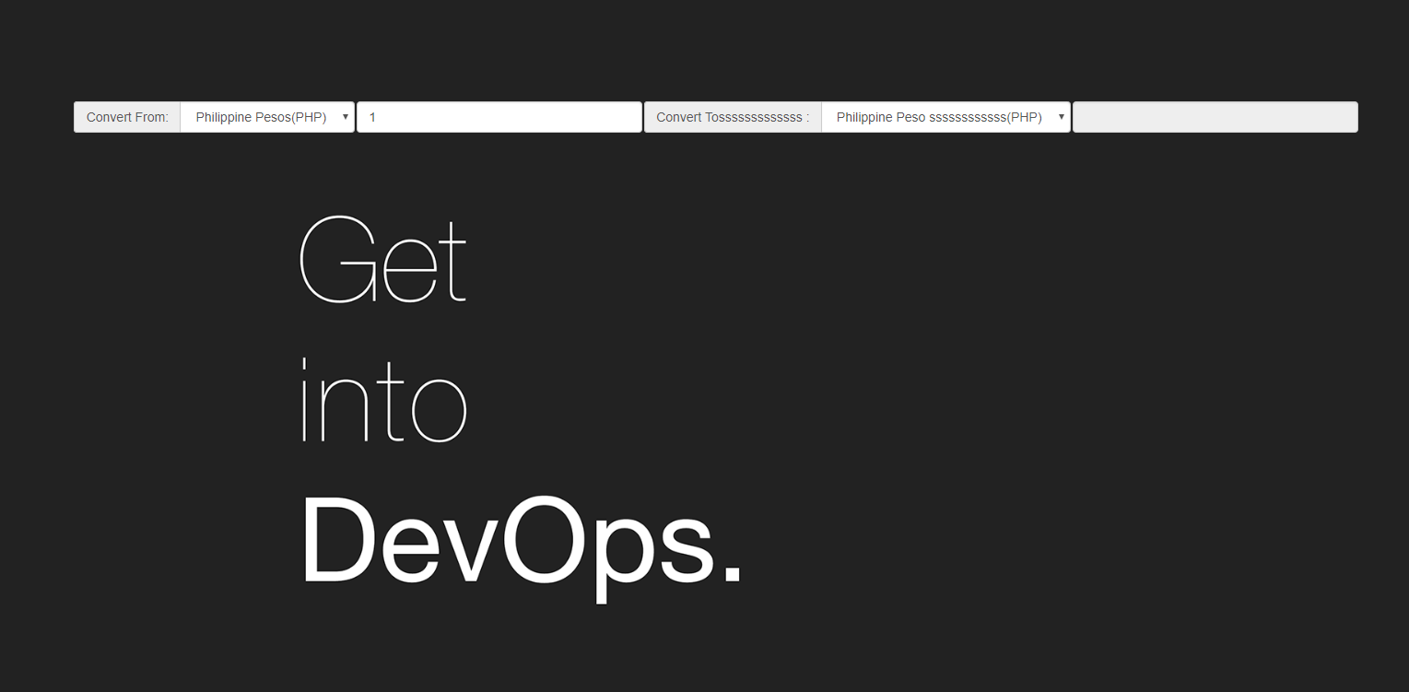

OTHER CONFIGURATION:

* Gitlab Connection

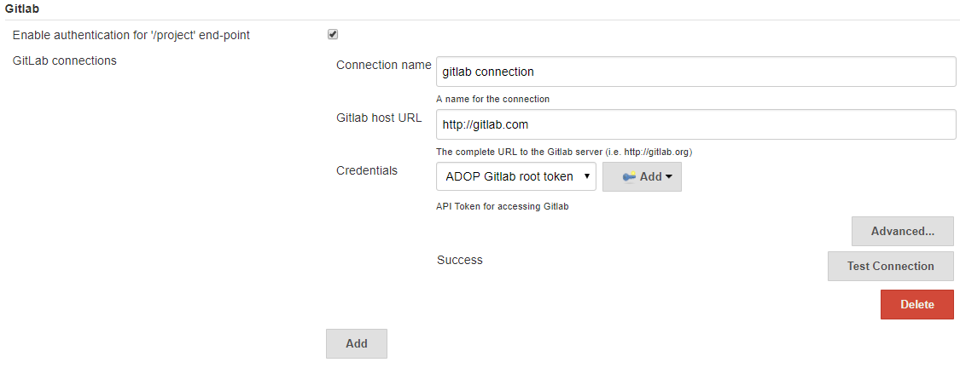  
  
  
  
  
  
  
  
  
  
  
  
  
  
  
  
  
GITLAB CONFIGURATION

1. ANSIBLE-DEPLOY
   1. 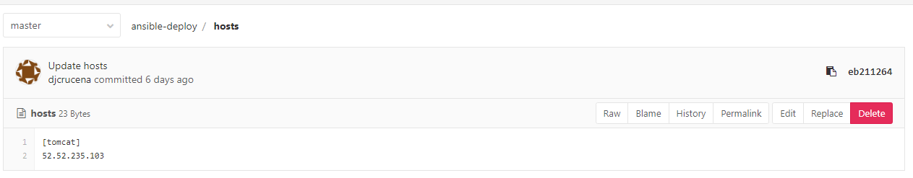Hosts
   2. Download_war -Tasks

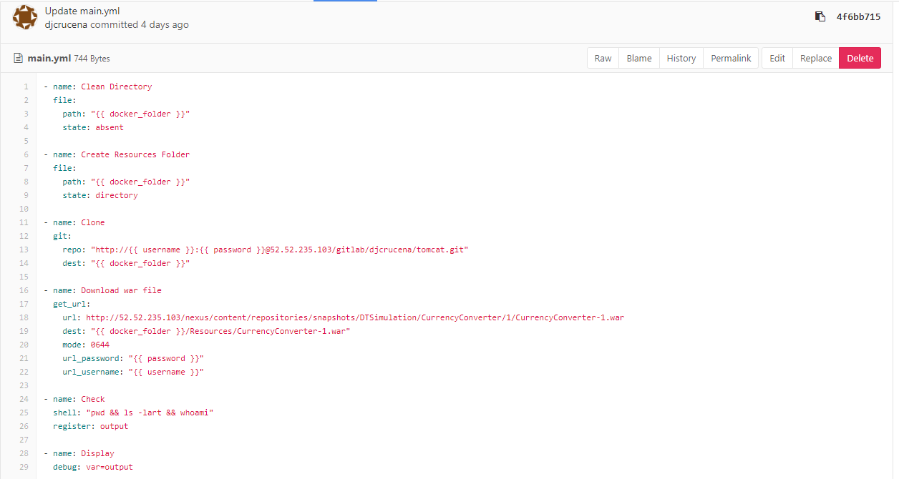

* 1. Deploy_war – Tasks  
     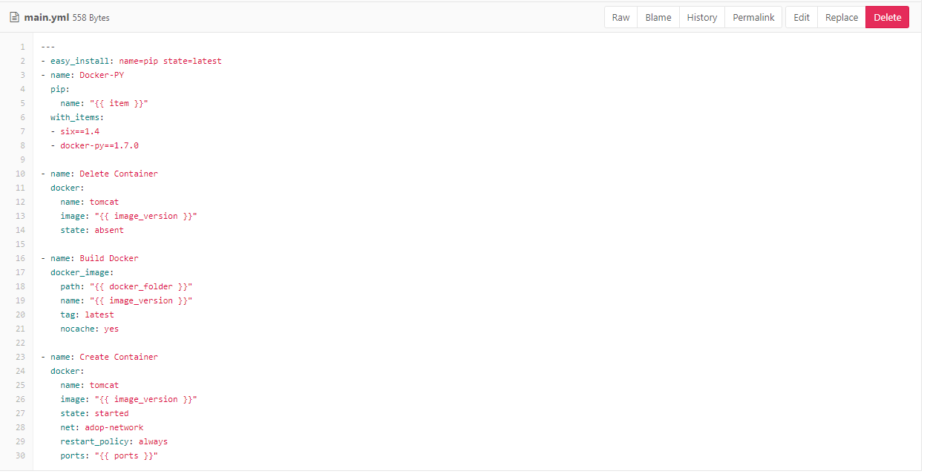

1. CURRENCY CONVERTER
2. Webhooks

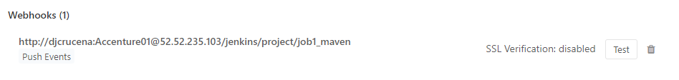

|  |  |  |  |  |
| --- | --- | --- | --- | --- |
| **GROUP** | **MEMBERS** | **DOCUMENTATION** | **PRESENTATION** | **TOTAL GRADE** |
| Group 1 | Garfin, Jose R. A | 8 | 8 | 8 |
| Ilagan, John R. C. | 8 | 9 | 8.5 |
| Magpantay, Lloyd H. M. | 8 | 8 | 8 |
| Group 2 | Grajo, Ronel A. | 8 | 8 | 8 |
| Mesina, Marjorie P. | 8 | 7.5 | 7.75 |
| Regala, Roman N. | 8 | 8 | 8 |
| Group 3 | Corpuz, Julius Ian B | 8 | 7.5 | 7.75 |
| Policarpio, Argel C. | 8 | 8 | 8 |
| Siwa, Nicolas E. A. | 8 | 7.5 | 7.75 |
| Group 4 | Anonuevo, Mel V. C. | 7.5 | 7.5 | 7.5 |
| Cruz, Kean Miguel S. | 7.5 | 7.5 | 7.5 |
| Llanes, Reuben D. M. | 7.5 | 8 | 7.75 |
| Group 5 | Bonador, John David G. | 8 | 8 | 8 |
| Gupit, Cleo Paul M | 8 | 8 | 8 |
| Isidro, Michael B. C. | 8 | 9 | 8.5 |